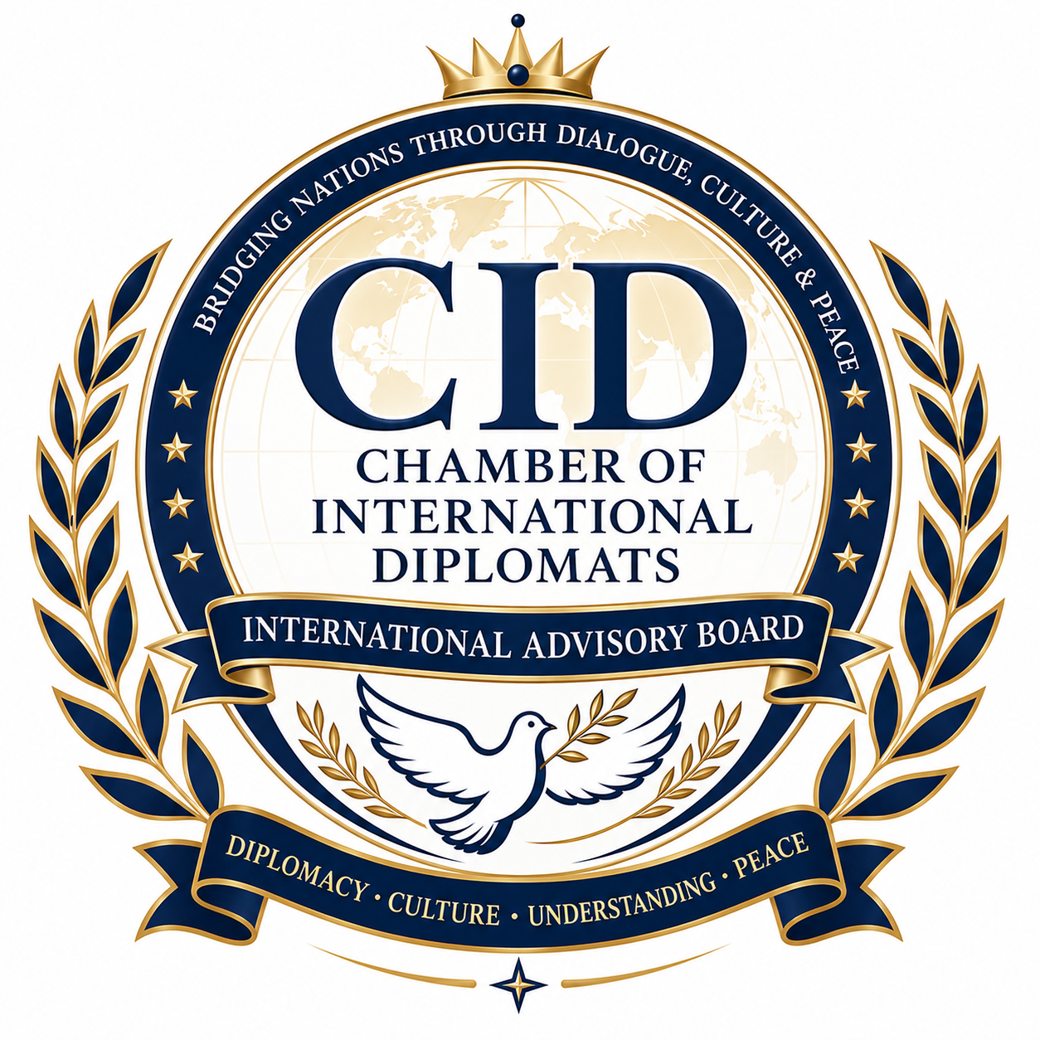
# CID Chamber of International Diplomats (CID)
INTERNATIONAL ADVISORY BOARD
## International Cultural Diplomacy Project 2026–2030

### “Bridging Nations Through Culture, Dialogue, and Peace”

**Prepared for: ** CID Chamber of International Diplomats (CID)
**Project Period: ** January 2026 – December 2030
**Project Type: ** International Cultural Diplomacy and Global Cooperation Initiative

# 1. Executive Summary

The **International Cultural Diplomacy Project 2026–2030** is a global initiative of the **CID Chamber of International Diplomats (CID)** designed to strengthen international understanding, peacebuilding, intercultural dialogue, and sustainable development through cultural diplomacy.

The project seeks to bring together diplomats, academics, artists, writers, cultural institutions, youth leaders, indigenous communities, and civil society organizations from all regions of the world to promote mutual respect among nations and civilizations.

Through international conferences, cultural festivals, educational exchanges, artistic collaborations, research programs, and diplomatic dialogue platforms, CID will establish itself as a leading global institution promoting cultural diplomacy for peace and international cooperation.

# 2. Vision

To create a world where cultures serve as bridges of peace, friendship, understanding, and cooperation among nations.

# 3. Mission

To advance international peace, mutual understanding, and sustainable global partnerships through cultural exchange, diplomacy, education, arts, heritage preservation, and intercultural dialogue.

# 4. Core Objectives

### Strategic Objective 1

Promote intercultural dialogue and mutual understanding among peoples and nations.

### Strategic Objective 2

Strengthen diplomatic relations through cultural engagement and people-to-people diplomacy.

### Strategic Objective 3

Preserve and promote world cultural heritage and cultural diversity.

### Strategic Objective 4

Empower youth and future leaders through cultural diplomacy education.

### Strategic Objective 5

Support peacebuilding initiatives through arts, literature, education, and cultural cooperation.

### Strategic Objective 6

Develop international partnerships among governments, embassies, universities, academies, museums, and cultural organizations.

# 5. Strategic Pillars

## Pillar I: Cultural Exchange and International Friendship

Activities:

* International cultural festivals
* Cultural heritage exhibitions
* International arts and crafts fairs
* Literary and poetry forums
* Traditional music and dance performances
* Cultural ambassadors program

Expected Outcomes:

* Increased intercultural awareness
* Strengthened people-to-people relations
* Enhanced international cultural cooperation

## Pillar II: Education and Academic Diplomacy

Activities:

* Cultural diplomacy certificate programs
* International academic exchange programs
* Research fellowships
* International lecture series
* Cultural diplomacy summer schools
* Joint academic publications

Expected Outcomes:

* Greater academic cooperation
* Increased cultural diplomacy expertise
* Development of future diplomatic leaders

## Pillar III: Youth Cultural Diplomacy Network

Activities:

* Global Youth Cultural Diplomacy Forum
* International youth leadership academy
* Student exchange initiatives
* Cultural innovation competitions
* Youth ambassador programs

Expected Outcomes:

* Youth engagement in diplomacy
* Leadership development
* International networking opportunities

## Pillar IV: Arts for Peace Initiative

Activities:

* International peace art exhibitions
* Global poetry and literature festivals
* Cultural diplomacy film festivals
* International music for peace concerts
* Artistic collaboration projects

Expected Outcomes:

* Promotion of peace through creative expression
* Cross-cultural artistic cooperation
* Increased public awareness of peace initiatives

## Pillar V: Heritage Preservation and Cultural Sustainability

Activities:

* Heritage documentation projects
* Cultural preservation workshops
* Indigenous culture promotion programs
* Museum partnerships
* Cultural tourism diplomacy initiatives

Expected Outcomes:

* Protection of cultural heritage
* Increased awareness of cultural diversity
* Strengthened cultural sustainability

## Pillar VI: Digital Cultural Diplomacy Platform

Activities:

* Virtual cultural exhibitions
* Online diplomacy forums
* Digital heritage archives
* International webinars
* Global cultural networking portal

Expected Outcomes:

* Global accessibility
* Enhanced international participation
* Increased digital cooperation

# 6. Flagship Programs

## 1. World Cultural Diplomacy Congress

Annual international congress gathering:

* Diplomats
* Ambassadors
* Cultural leaders
* Academics
* Artists
* International organizations

Purpose:

* Exchange best practices
* Promote cultural cooperation
* Develop international partnerships

## 2. International Cultural Diplomacy Awards

Annual awards recognizing excellence in:

* Peace building
* Cultural cooperation
* Arts and culture
* Education
* Heritage preservation
* International diplomacy

## 3. Global Cultural Ambassadors Program

Appointment of distinguished:

* Diplomats
* Academics
* Artists
* Authors
* Humanitarian leaders

To represent CID cultural diplomacy initiatives worldwide.

## 4. International Festival of Cultures

Annual multicultural event featuring:

* National pavilions
* Music performances
* Traditional cuisine
* Cultural exhibitions
* Educational forums

## 5. UNESCO-CID Cultural Cooperation Initiative

Potential cooperation with:

* UNESCO
* National UNESCO Commissions
* International cultural organizations

Areas:

* Heritage protection
* Cultural education
* Sustainable development
* Peace building

# 7. International Partnerships

Potential partners:

### International Organizations

* UNESCO
* United Nations Alliance of Civilizations (UNAOC)
* International Organization of La Francophonie
* Organization of American States
* African Union cultural institutions
* Arab League cultural organizations

### Academic Institutions

* Universities
* National Academies of Sciences and Arts
* Research institutes
* Cultural diplomacy centers

### Government Institutions

* Ministries of Foreign Affairs
* Ministries of Culture
* National cultural councils
* Embassies and diplomatic missions

# 8. Implementation Timeline

## Phase I (2026)

Foundation and Launch

* Establish International Steering Committee
* Launch digital platform
* Begin partnership development
* Organize inaugural congress

## Phase II (2027)

Expansion

* Launch youth network
* Initiate ambassador program
* Establish regional chapters
* Organize international cultural festivals

## Phase III (2028)

Global Outreach

* Expand partnerships to 50+ countries
* Launch fellowship programs
* Conduct regional conferences

## Phase IV (2029)

Consolidation

* Evaluate program impact
* Strengthen international networks
* Publish Global Cultural Diplomacy Report

## Phase V (2030)

Global Summit and Future Strategy

* Organize World Cultural Diplomacy Summit
* Present international awards
* Publish 2031–2035 strategic roadmap

# 9. Expected Impact by 2030

* Participation from over **100 countries**
* More than **10,000 participants**
* Establishment of **regional cultural diplomacy chapters**
* Creation of an international network of cultural ambassadors
* Publication of annual cultural diplomacy reports
* Increased international cooperation through cultural engagement
* Promotion of peace, tolerance, and mutual understanding worldwide

# 10. Project Governance

### Patron

President, CID Chamber of International Diplomats

### International Advisory Board

Chairperson: **Prof. Dr. Kemal Yildirim**

### Steering Committee

* Diplomats
* Academics
* Cultural experts
* International relations specialists
* Youth representatives

### Secretariat

CID Chamber of International Diplomats Headquarters

# Motto

**“Culture Unites Humanity – Diplomacy Builds Peace.”**

**Prepared for the CID Chamber of International Diplomats (CID)**
**International Cultural Diplomacy Project 2026–2030**
**Promoting Global Understanding, Cultural Cooperation, and Lasting Peace Through Diplomacy.**

